To be considered for remote access/ work from home (WFH), IVIRMA requires your home PC or laptop to meet our minimum specifications for equipment here in the offices. Please read through this document in its entirety before beginning.
We require anyone who is requesting WFH to submit their PC or laptop’s specifications:
- Processor – on PC usually an “I” followed by a number, on Mac this can be an “I” or an “M”.
- Memory – also known as RAM, how many GBs do you have?
- Storage – is it a hard drive (HD or HDD) or solid-state drive (SSD)?
- Operating System/OS – What version of Windows/macOS are you running?
- What type of external display ports do you have?
Chromebooks are not eligible devices for WFH.

Please provide us with the type and number of ports your PC or laptop has. Please refer to the following images for an easy guide to identifying the ports:
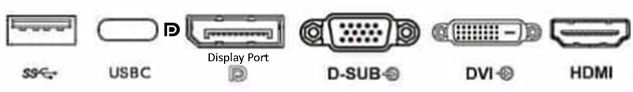
*Note the USB-C port must have the little D symbol next to it to be compatible

Windows: Download and run Speccy (https://www.ccleaner.com/speccy/download/standard)
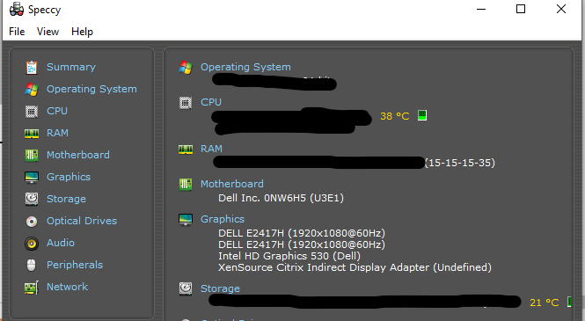
Mac users: You can find your details by selecting Apple menu > About This Mac: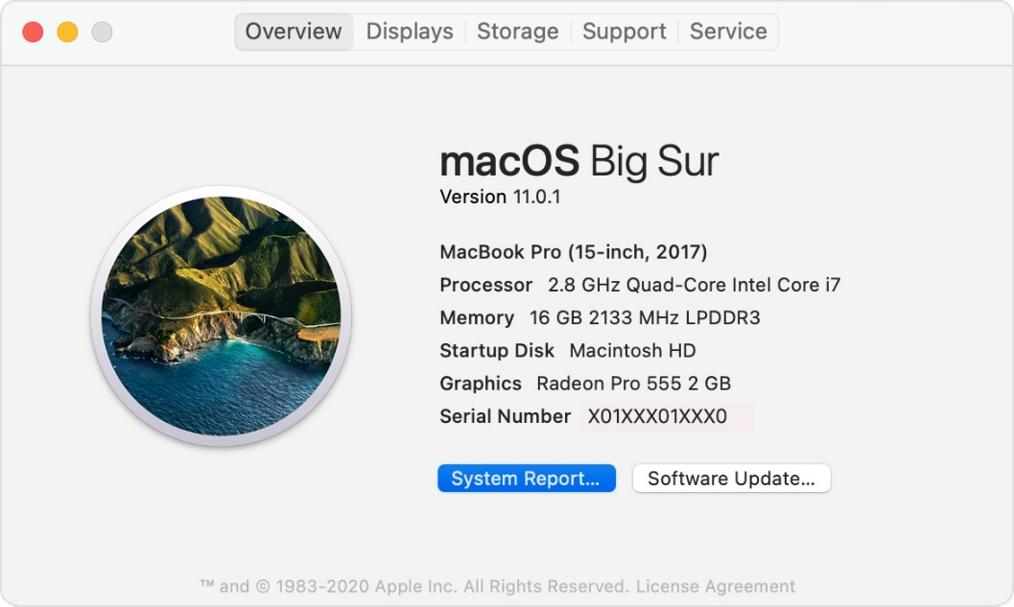
Here you will find your OS name and version, processor, and memory. Click on “System Report” to see the Storage information. Select “Storage” on the list to see what type of storage (HDD or SSD) you have.

Finally, your home network (internet/Wi-Fi) must meet the following criteria:
You can use this free test from Cloudflare to find all the information required:
Internet Speed Test (https://speed.cloudflare.com/)

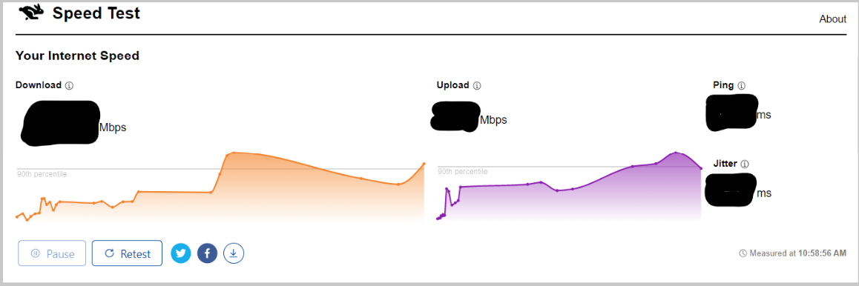

Please complete the following and submit to your supervisor:

Employee Name:
Email Address:
System
Processor:
Memory:
Storage:
OS:
Network
Download:
Upload:
Ping:
Jitter:
Ports
HDMI:
DisplayPort:
USB-C with DisplayPort symbol:

